JM Hammond

**Yōga** (洋画)

The term Yōga is used in Japan to refer to Western-style art. It is often used to specifically denote oil paintings but more widely can refer to a range of imported methods, such as watercolors, pencil drawing, etching and lithography. It is this concern with materials that has traditionally distinguished Yōga from Japanese methods of art production, rather than reference to Western pictorial devices such as fixed-point perspective. As a result of missions from Europe arriving in the 16th century, Japan’s earliest forays into Yōga were Christian paintings, at least until the religion was outlawed under the Tokugawa Shogunate, which also implemented a policy of national seclusion. But it lifted its ban on foreign books in the early 18th century, and a limited number of painters, notably Satake Shozan, Hiraga Gennai and Shiba Kōkan, turned their hand to oil painting. But the category of Yōga was not established until the after the full-scale opening of Japan to the outside world in the mid-19th century. In 1856 the Shogun founded a bureau for research into Western studies, including art (the Bansho Shirabesho). One of its students, Takahashi Yuichi (1828-1894), later became a pioneer of Yōga (see image: *Salmon* of 1877).

By this time, the Shogun had been overthrown and the new government of Meiji-era Japan began to pursue modernization, which it initially conflated with Westernization. The government-run Technical Art School (Kobu Bijutsu Gakko) opened in 1876 with teachers contracted from Italy, notably Antonio Fontanesi (1818 -1882). The emphasis on modelling, chiaroscuro and perspective reflected the desire to modernize Japan and strengthen its industrial base through technical drawing rather than support for culture and aesthetics. Decoration of the increasing number of Western-style public buildings was a further aim, however, and Fontanesi also taught oil painting, mainly in the mode of the Barbizon school.

This style informed the work of his students such as Asai Chū (1856-1907),who,along with Takahashi Yuichi and others, actively promoted Yōga (and were later active in the Meiji Fine Arts Society, established 1889). However, increasingly nationalist sentiment turned against Yōga in the 1880s as thinkers and artists such as Okakura Kakuzō (Okakura Tenshin, 1863-1913) promoted a modernized Japanese art style (Nihon-ga) and succeeded in making sure Yōga was not on the curriculum when the government opened the Tokyo School of Fine Arts in 1887.

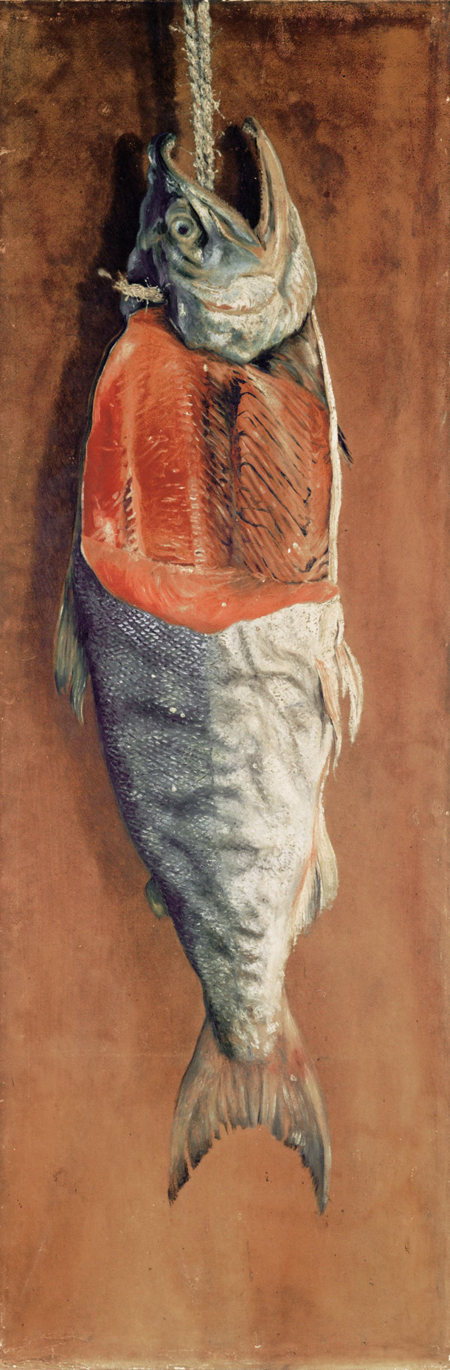

Takahashi Yuichi, *Salmon* 1877, oil on canvas, Tokyo University of Arts

Japan’s ambivalent attitude is illustrated in the reverse course that saw Kuroda Seiki (1866-1924) sworn in as director of the school’s new Department of Western Art in 1896. The new head brought in teachers of the caliber of Fujishima Takeji (1867-1943) and firmly re-established Yōga, alongside Nihonga and sculpture, as one pillar of art education.

Kuroda had been in France through most of the 1880s studying under Raphaël Collin (1850-1916) and used his teacher’s Impressionist-tinged academic style as the template for his own work. This superseded the style of the Society to become the official face of Yōga. It held fast until met by resistance, in the 1910s, by a new generation of artists under the sway of post-Impressionism, and, in some cases nativist ideas.

**References and Further Reading**

Clark, John. (1995) ‘Yōga in Japan: Model or Exception? Modernity in Japanese Art 1850s-1940s: An International Comparison,’ in *Art History*, vol 18, no. 2, p. 252-285.

Clark, John. (2013) *Modernities of Japanese Art*, Leiden & Boston: Brill.

Kuroda Seiki. (2006), *Kindai Nihon Yōga no Kyoshō*, Tokyo: Toyoda-shi Bijutsukan. (In Japanese)

Shuji Takashina, J. Thomas Rimer, and Gerald Bolas, eds. (1987) *Paris in Japan,* Tokyo and St. Louis: Japan Foundation and Washington University in St. Louis.

Winther-Tamaki, Bert. (2012) *Maximum Embodiment: Yōga, the Western Painting of Japan, 1912-1955*, Honolulu: University of Hawaii Press.